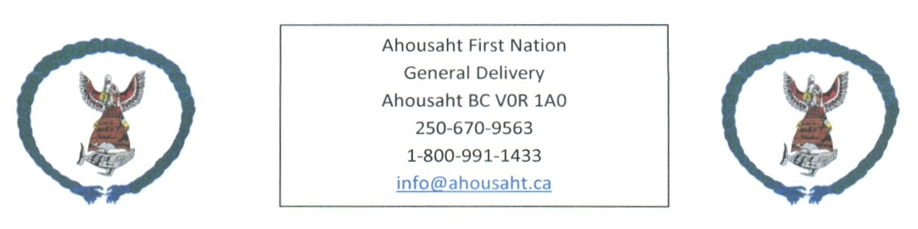

Ahousaht Covid Update
October 4, 2021

Covid19 has been in our community since September 4th, 2021

Active Cases - 8
In community | 3
Away from home | 5

Recovered – 67
In Community | 48
Away from home | 19

Cases Total – 75

Households – 5

We have members who continue to isolate and/or recover

Vaccinated
 | 1 vaccine | 2 vaccines
18 and over | 508 | 428
12 – 17 years | 57 | Awaiting confirmation information from CHS

Hospitalized Cases – 2

Vancouver Island Region – Active cases
North Van Island | 45
Central Vancouver Island | 240
Southern Vancouver Island | 312

Partying: Great concerns from Family, Leadership and Health staff are the partying. We need everyone to help get our family members home, to bring them home.

Isolation: Support, we encourage for homes in isolation have a tote outside for people to drop off items.
If you are interested, we can provide with a care kit (per home), email eoc@ahousaht.ca

Any questions or recommendations, email eoc@ahousaht.ca

